**Design Document – G00359748 (Shane McCormack)**

For my project I have decided to design a game in which the user collects as much coins as possible in thirty seconds to get the best score as possible.Each coin contains the score in every one.The user has to avoid the bombs coming down on them to avoid a deduction on their score.

The scoring system for the points are as follows:

The coin is worth 50 points

The bomb deducts 100 points from the scoreboard

There will be a time of 30 seconds to score as much points as possible and to avoid any deductions along the way.Once the time starts you will have to start moving using the controls in order to go through the coins to get the points to add to your score.The player is a helicopter because the player has to fly up in the sky to retrieve some of the coins while some of them are down on the ground.The highest score in a single game is displayed on the screen and obviously it’s the players mission to beat that score and make the highest score their own so if they were to achieve that they could put it in so it would be displayed in the next game.The score does not carry on to the second level as they are separate from one another so there are two different highest score records.

**Front End**

What I have done at the start is welcoming the user to the game which allows them to enter the game.

Then the user will be asked to either to play the game, the option to look at the instructions of the game including controls, or go into the credits section or even quit the game.

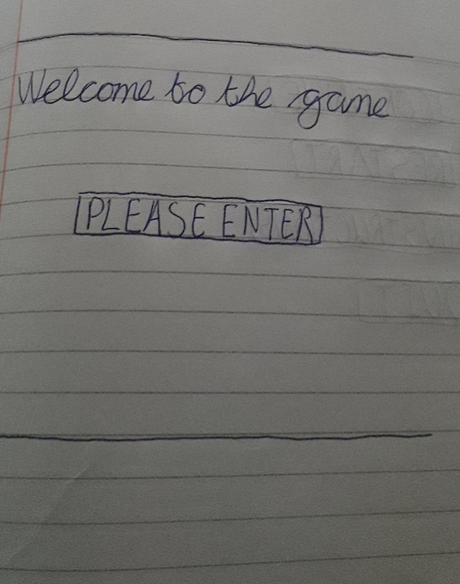

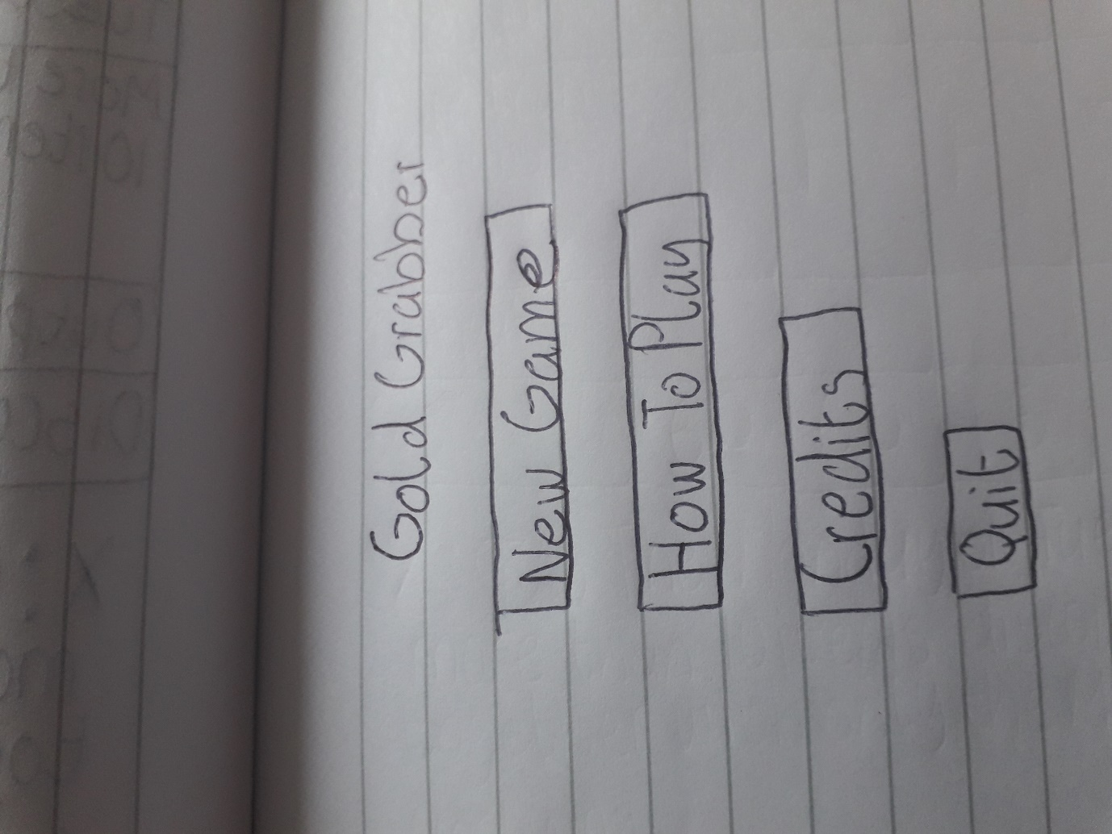

**In Game Menus**

While playing the game you can pause the game by pressing the down button and the escape button at the same time and you can choose a list of options including to continue to play the game, or to quit the game or go back to the main menu if the player wishes to start a new game.

**Control Mechanisms**

For the controls you move the left and right arrows to move the player left and right.You then use the space bar to move up into the sky where some of the coins can be retrieved and to also avoid the incoming bombs.

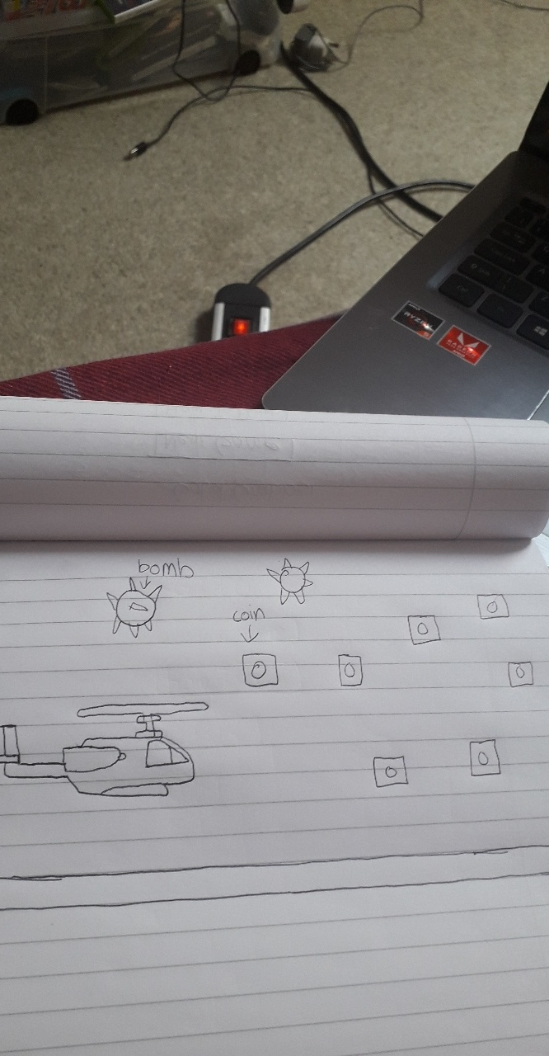

**The Game**

The game will have a brighter background at first to represent the day and then it will scroll into a darker background to represent the night.The score is displayed at the bottom of the screen along with the timer and the high score.When the timer ends the game it then moves onto the second level where there are more coins to be got but also there’s more bombs in the game which increases the risk of your points being decreased.

**Player**

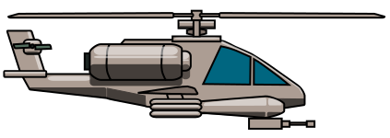

I used a helicopter for the player because if the player was able fly then it would only make sense that I would pick something that could actually go into the air and retrieve coins.



**Enemy**



I used a bomb for the enemy to deduct points from the scoreboard.The concept of this idea was because on how a bomb destroys stuff so I thought it could destroy some points of the scoreboard.

**Research**

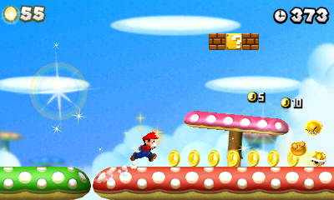

I looked up games that are similar to this one that I’m creating and one that stuck out because it is well known was the Super Mario Bros game. Both games are similar in terms of collecting coins but while the score is different on this one regarding the amount of coins it collects while in my one there’s 50 points for every coin that’s collected and -100 points taken away for every bomb collected.